***Chemistry***

**12: Kinetics**

**12.1: Chemical Reaction Rates**

1. What is the difference between average rate, initial rate, and instantaneous rate?

Solution

The instantaneous rate is the rate of a reaction at any particular point in time, a period of time that is so short that the concentrations of reactants and products change by a negligible amount. The initial rate is the instantaneous rate of reaction as it starts (as product just begins to form). Average rate is the average of the instantaneous rates over a time period.

3. In the nuclear industry, chlorine trifluoride is used to prepare uranium hexafluoride, a volatile compound of uranium used in the separation of uranium isotopes. Chlorine trifluoride is prepared by the reaction  Write the equation that relates the rate expressions for this reaction in terms of the disappearance of Cl2 and F2 and the formation of ClF3.

Solution

Write the rate of change with a negative sign for substances decreasing in concentration (reactants) and a positive sign for those substances being formed (products). Multiply each term by the reciprocal of its coefficient:



5. A study of the rate of the reaction represented as gave the following data:

|  |  |  |  |  |  |  |  |
| --- | --- | --- | --- | --- | --- | --- | --- |
| Time (s) | 0.0 | 5.0 | 10.0 | 15.0 | 20.0 | 25.0 | 35.0 |
| [*A*] (*M*) | 1.00 | 0.775 | 0.625 | 0.465 | 0.360 | 0.285 | 0.230 |

(a) Determine the average rate of disappearance of *A* between 0.0 s and 10.0 s, and between 10.0 s and 20.0 s.

(b) Estimate the instantaneous rate of disappearance of *A* at 15.0 s from a graph of time versus [*A*]. What are the units of this rate?

(c) Use the rates found in parts (a) and (b) to determine the average rate of formation of *B* between 0.00 s and 10.0 s, and the instantaneous rate of formation of *B* at 15.0 s.

Solution

Plot the concentration against time and determine the required slopes:

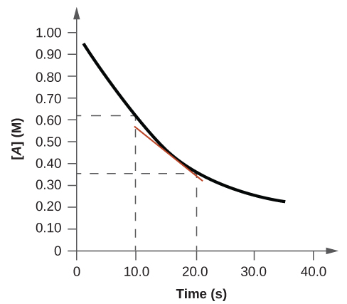

(a) Average rates are computed directly from the reaction’s rate expression and the specified concentration/time data:  
average rate, 

average rate,;

(b) The instantaneous rate is estimated as the slope of a line tangent to the curve at 15 s. Such a line is drawn in the plot, and two concentration/time data pairs are used to estimate the line’s slope:

instantaneous rate, ;

(c) To derive rates for the formation of *B* from the previously calculated rates for the disappearance of *A*, we consider the stoichiometry of the reaction, namely, *B* will be produced at one-half the rate of the disappearance of *A*:



average rate for B formation = 

instantaneous rate for B formation = 

This resource file is copyright 2015, Rice University. All Rights Reserved.